B1:

2 desirable properties of good hash function are:

* Fast to compute.
* Minimize the duplication of output values (collisions).

B2:

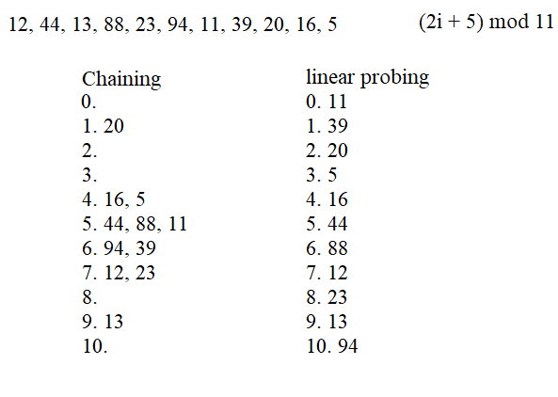

B3:

